21 When implementing linear regression of some dependent variable 𝑦 on the set of independent variables 𝐱 = (𝑥₁, …, 𝑥ᵣ), where 𝑟 is the number of predictors, which of the following statements will be true?

1. 𝛽₀, 𝛽₁, …, 𝛽ᵣ are the **regression coefficients**.
2. Linear regression is about determining the **best predicted weights** by using the **method of ordinary least squares**.
3. E is the random interval
4. Both and b

Ans- Both A and B

22 )

What indicates that you have a **perfect fit** in linear regression?

1. The value 𝑅² < 1, which corresponds to SSR = 0
2. The value 𝑅² = 0, which corresponds to SSR = 1
3. The value 𝑅² > 0, which corresponds to SSR = 1
4. The value 𝑅² = 1, which corresponds to SSR = 0

## Ans -D

23)

In simple linear regression, the value of **what** shows the point where the estimated regression line crosses the 𝑦 axis?

1. Y
2. B0
3. B1
4. F

And -B

24)

Check out these four linear regression plots:

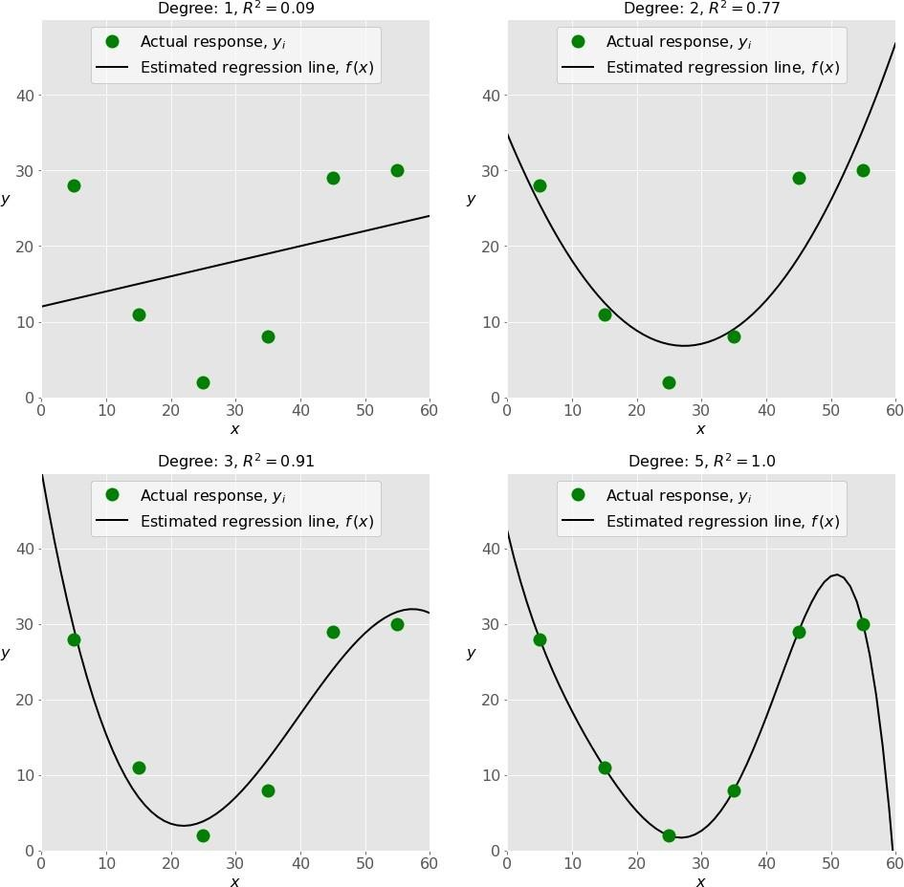

Which one represents an **underfitted** model?

1. The bottom-left plot
2. The top-right plot
3. The bottom-right plot
4. The top-left plot

## Ans-D

25)

There are five basic steps when you’re implementing linear regression:

* + **a.** Check the results of model fitting to know whether the model is satisfactory.
  + **b.** Provide data to work with, and eventually do appropriate transformations.
  + **c.** Apply the model for predictions.
  + **d.** Import the packages and classes that you need.
  + **e.** Create a regression model and fit it with existing data.

However, those steps are currently listed in the wrong order. What’s the correct order?

1. e, c, a, b, d
2. e, d, b, a, c
3. d, e, c, b, a
4. d, b, e, a, c

Ans-d

26 ) Which of the following are optional parameters to LinearRegression in scikit-learn?

1. Fit
2. fit_intercept
3. normalize
4. copy_X
5. n_jobs
6. reshape

## ans-All other than A and F

1. While working with scikit-learn, in which type of regression do you need to transform the array of inputs to include nonlinear terms such as 𝑥²?
2. Multiple linear regression
3. Simple linear regression
4. Polynomial regression

## Ans-C

1. You should choose statsmodels over scikit-learn when:

A)You want graphical representations of your data.

1. You’re working with nonlinear terms.
2. You need more detailed results.
3. You need to include optional parameters.

# Ans-C

1. is a fundamental package for scientific computing with Python. It offers comprehensive mathematical functions, random number generators, linear algebra routines, Fourier transforms, and more. It provides a high-level syntax that makes it accessible and productive.
2. Pandas
3. Numpy
4. Statsmodel
5. scipy

# Ans -B

30 ) is a Python data visualization library based on Matplotlib. It provides a high-level interface for drawing attractive and informative statistical graphics that allow you to explore and understand your data. It integrates closely with pandas data structures.

And -B

1. Bokeh
2. Seaborn
3. Matplotlib
4. Dash